OBAFEMI AWOLOWO UNIVERSITY, ILE-IFE, NIGERIA
FACULTY OF SOCIAL SCIENCES,
DEPARTMENT OF GEOGRAPHY

B.Sc. (Geography) Degree Examination
Rain Semester 2017/2018 Session

GPY 416: Micro-climatology

Instruction: Answer Question 1 and any other two (2) Questions Duration: 2hours

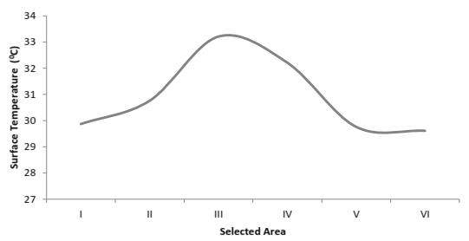
- The Figure 1 and Table 1 show the temperature profile for selected locations in Lagos. Based on information in the Table, why does the temperature value in the Figure 1 show the highest in location III and gradually decline towards the other locations?

Figure 1: Mean land surface temperature (LST) during dry season from MODIS data btw 2002 & 2014 for selected sites in Lagos Source: Ayanlade (2016) Model. Earth Syst. Environ. 2:193. DOI 10.1007/s40808-016-0238-z Springer
Table 1: Mean Seasonal Land Surface Temperature (SLST) from MODIS data between 2002 and 2014 for selected site.
Selected Site | Description | Mean SLST  Wet season | Mean SLST  Dry season
I | This area is mainly farmland area, located around Ota community in Ogun state, Northwest of Lagos. | 27.7 | 29.8
II | The zone is sub-urban residential areas, mainly along Alimosho community of Lagos, which consisting of urban fringe. | 28.8 | 30.7
III | This site is mainly commercial and downtown area, consisting of Ikeja and Ilupeju of Lagos, which is the core urban part of the study area. | 32.4 | 33.2
IV | This area consist of urban residential area, mainly the around Oshodi and Ijegun area. | 30.4 | 32.2
V | This site is located around sub-urban residential area with some green cover, mainly around Isawo area. | 28.0 | 29.7
VI | This is mainly rural area consist of vegetal cover and some houses, along Isiu community | 27.8 | 29.6
Source: Ayanlade (2016) Model. Earth Syst. Environ. 2:193. DOI 10.1007/s40808-016-0238-z Springer

- Critically discuss the climatic effects of the following, in terms of how they modify microclimate of an area:
- Ricks and sands
- Water surfaces
- Topography
- Snow and ice

- In relation to climate change, write comprehensive notes on:
- Climate change forcing agents
- Climate change impacts
- The importance of framework
- Climate variability

- Compare the microclimate of short growing crops surface with dry desert surface. Use diagrams to illustrate your answer.

- Describe five of the consequences of sea level rise on coastal cities and wildlife.

